# IMPLEMENTING CRM FOR RESULT TRACKING OF

# CANDIDATES WITH INTERNAL MARK

1. INTRODUCTION:

1.1 Overview:

Customer relationship management (CRM) is the combination of practices, strategies and technologies that companies use to manage and analyze customer interactions and data throughout the customer lifecycle. The goal is to improve customer service relationships and assist in customer retention and drive sales growth

They allow businesses to learn more about their target audiences and how to best cater for their needs, thus retaining customers and driving sales growth. CRM may be used with past, present or potential customers..

CRM stands for Customer Relationship Management, and it's a technology for managing and supporting customer relationships. CRM technology helps companies build and grow customer relationships across the entire customer lifecycle.

The beginnings of CRM as we know it started in the 1980s. Robert and Kate Kestnbaum were pioneers of database marketing. Which was a form of direct marketing that analysed the customer database statistically to identify which customers would be most likely to react to a marketing campaign?

The CRM cycle involves marketing, customer service and sales activities. It starts with outreach and customer acquisition and ideally leads to customer loyalty. There are five key stages in the CRM cycle: Reaching a potential customer. Customer acquisition

1.2.PURPOSE:

Customer relationship management (CRM) is a technology for managing all your company's relationships and interactions with customers and potential customers. The goal is simple: Improve business relationships. A CRM system helps companies stay connected to customers, streamline processes, and improve profitability

Basically, it helps nurture relationships with customers for long-term sales. Although the underlying principle in CRM is not to squeeze out more profits but to make customers happy, which in turn results in product loyalty and more revenues for the business.

2. PROBLEM DEFINITION & DESIGN THINKING

2.1 Empathy map:

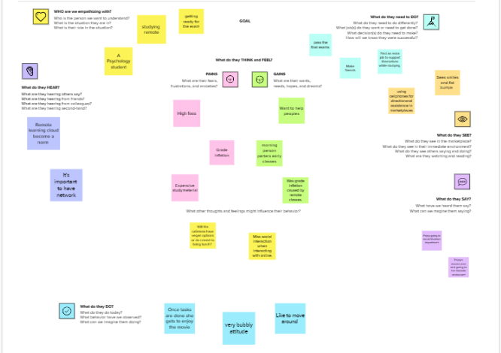

2.2 Ideation & Brainstroming Map: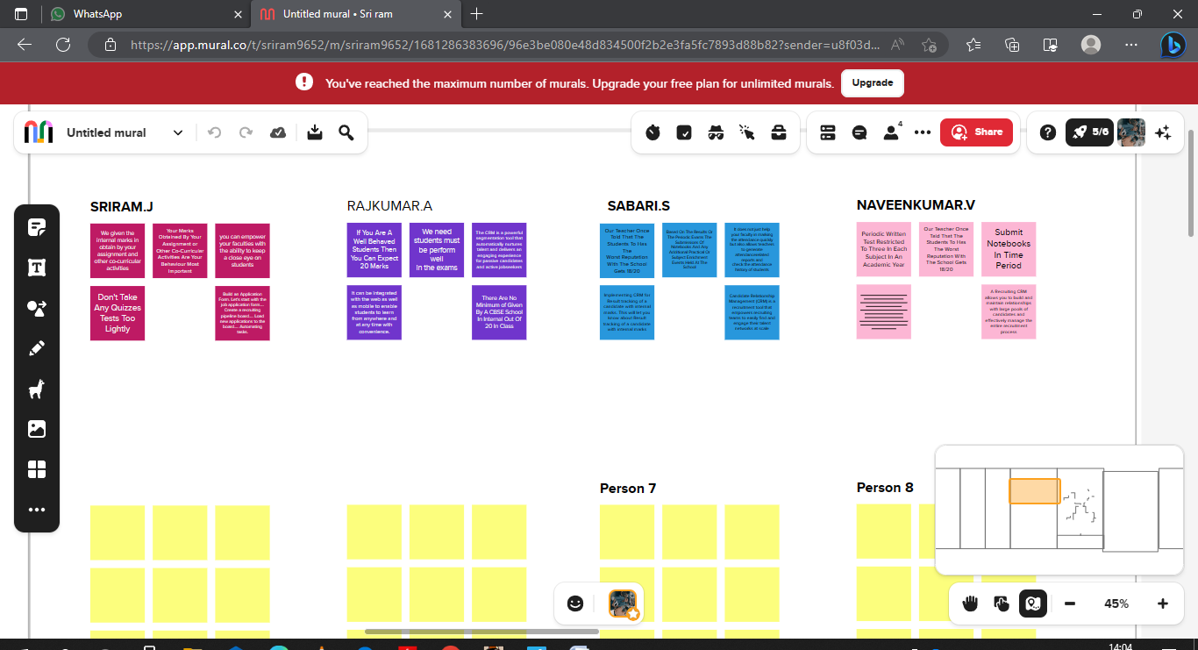

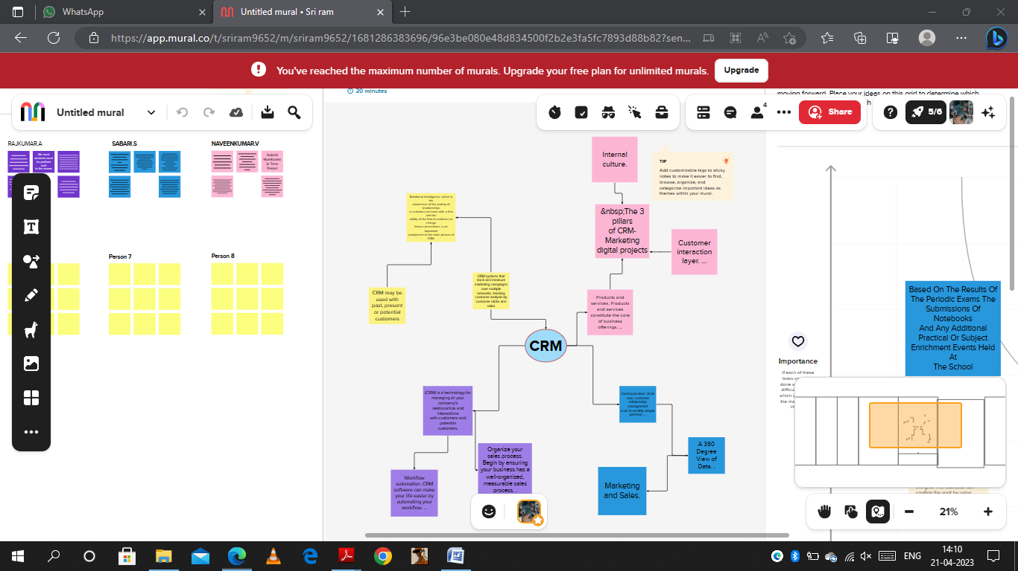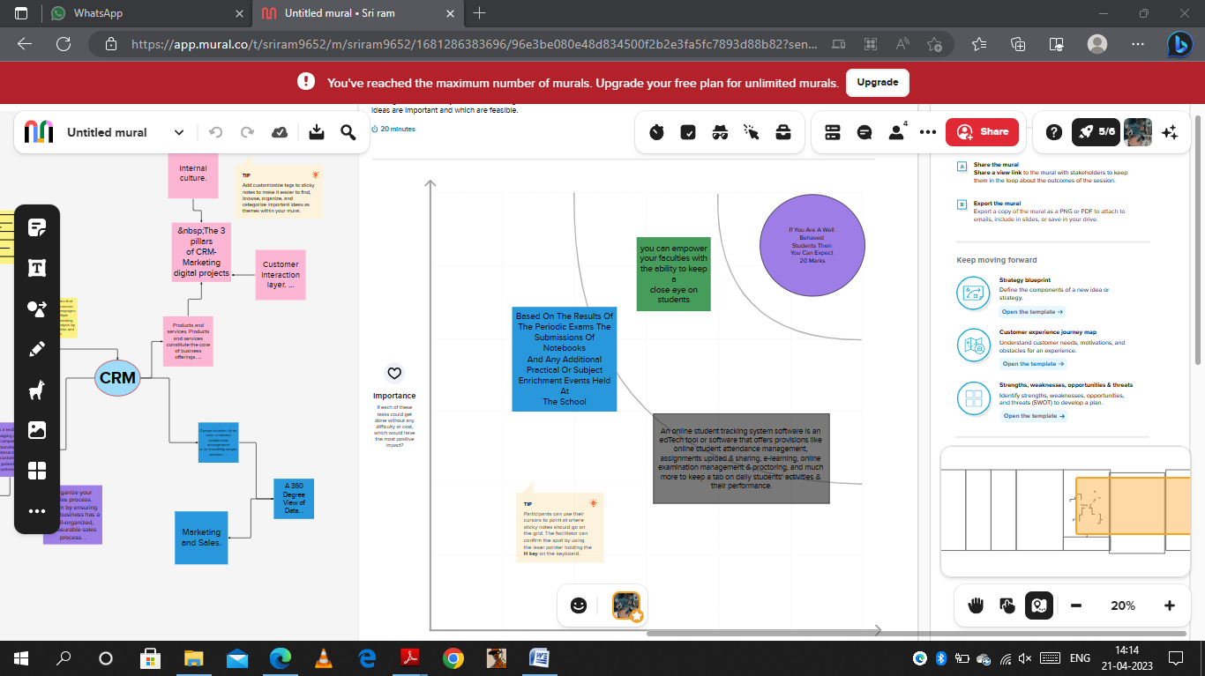

3. RESULT

3.1 Data model

|  |  |  |
| --- | --- | --- |
| Object name | Field in the object | |
| candidate | Field label | Data type |
| Account name | name |
| Account number | Text 40 |
| Account owner | Lookup user |
| Account site | text |
| Account source | picklist |
| Active | Picklist |
| Annual revenue | currency |
| Billing address | address |

3.2 Activity & screenshot:

MILESTONE -01:

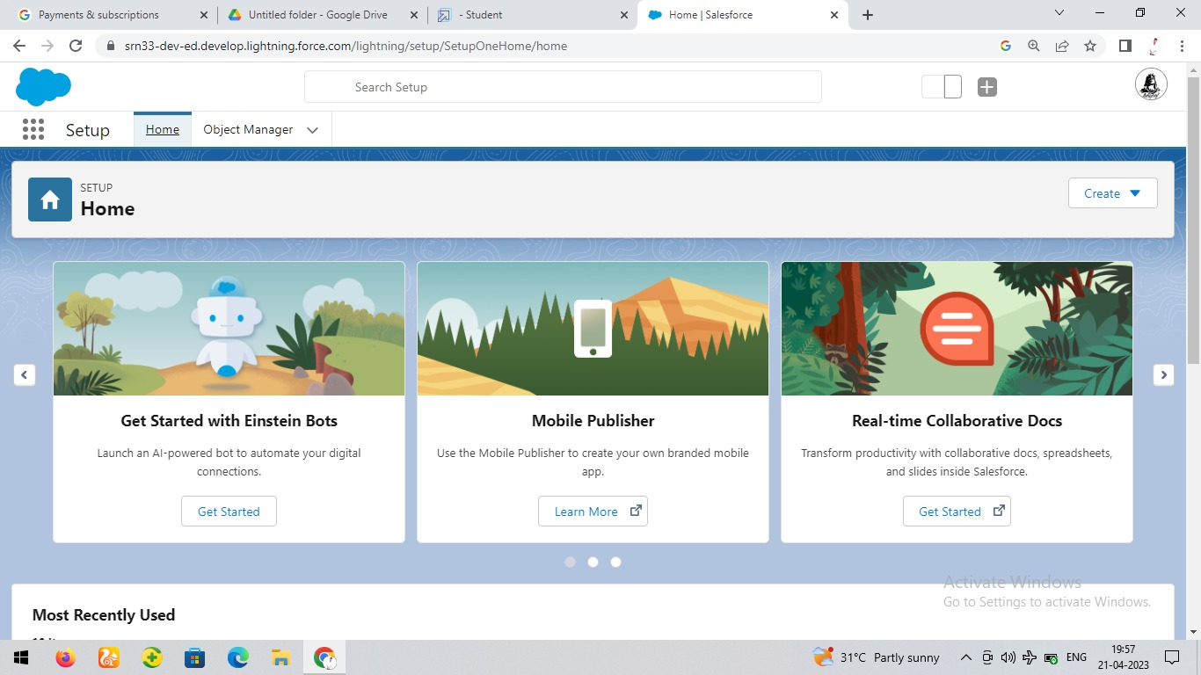

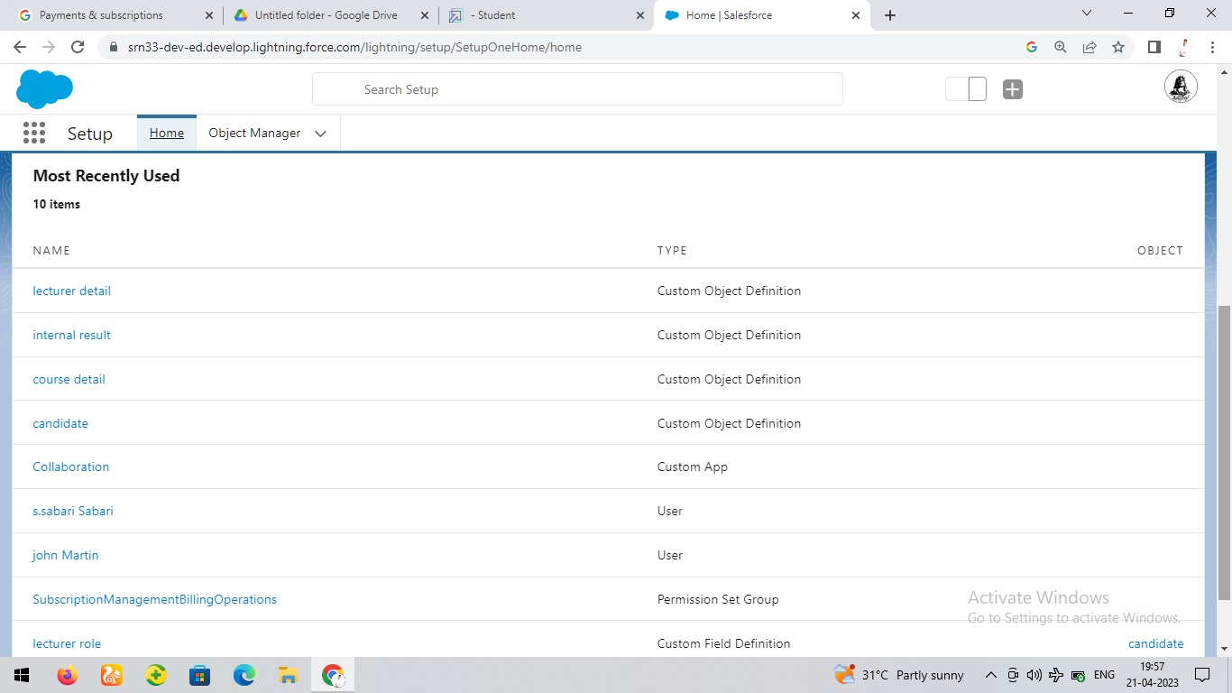

MILESTONE -02:

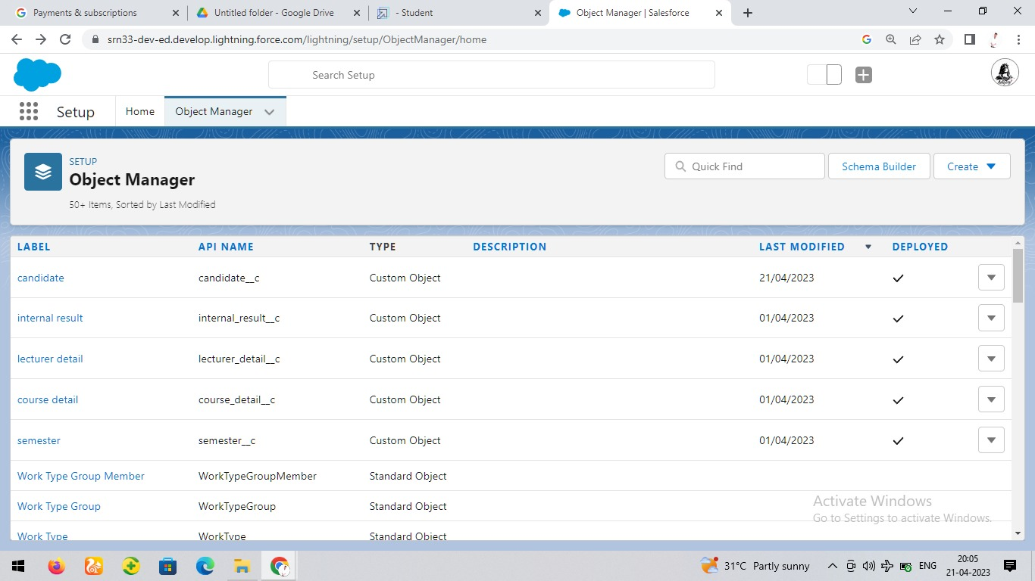

MILESTONE -03:

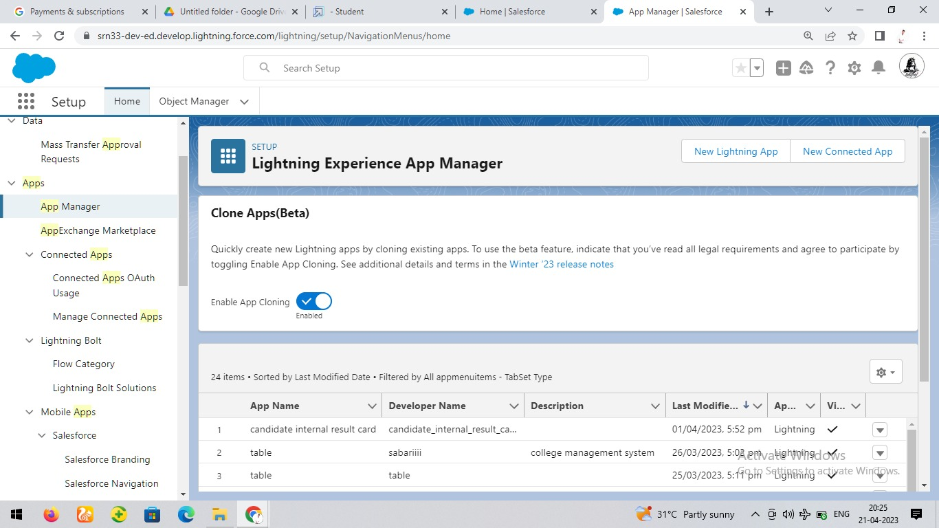

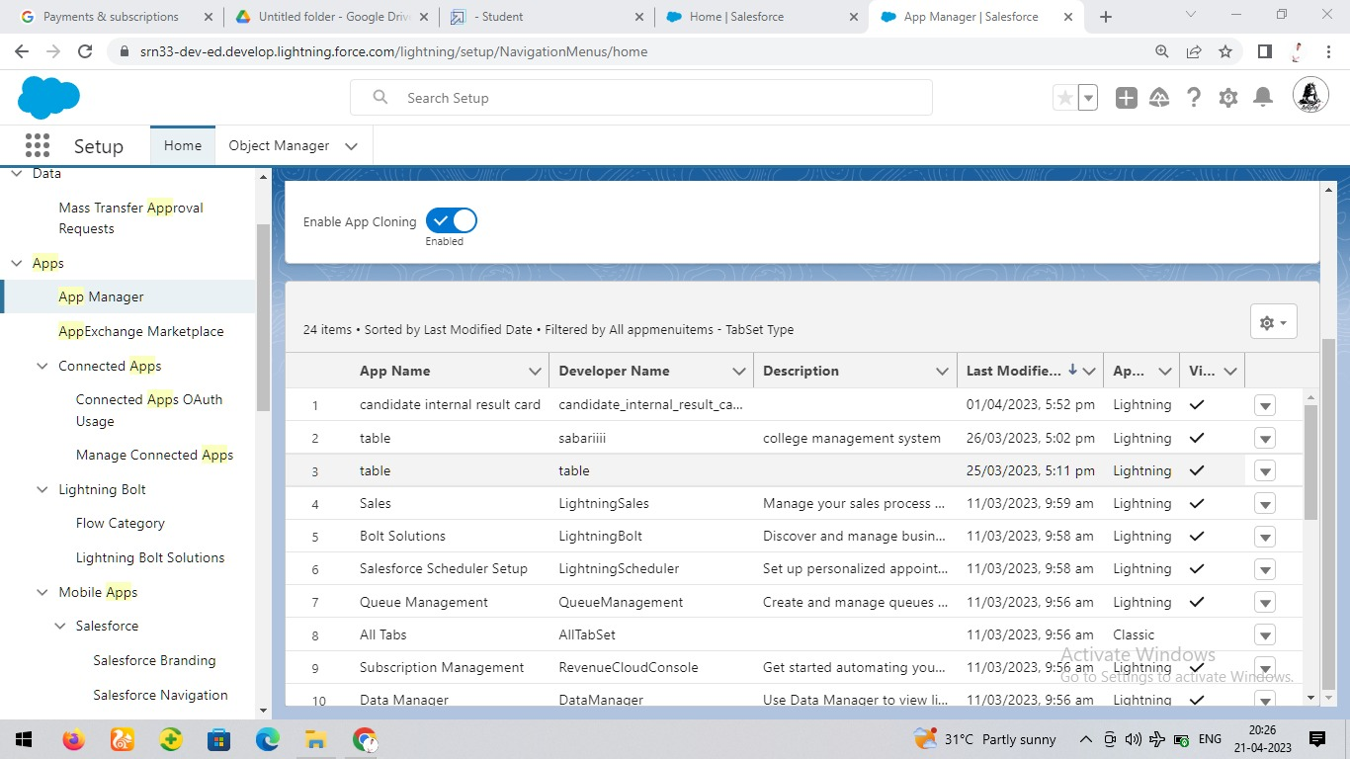

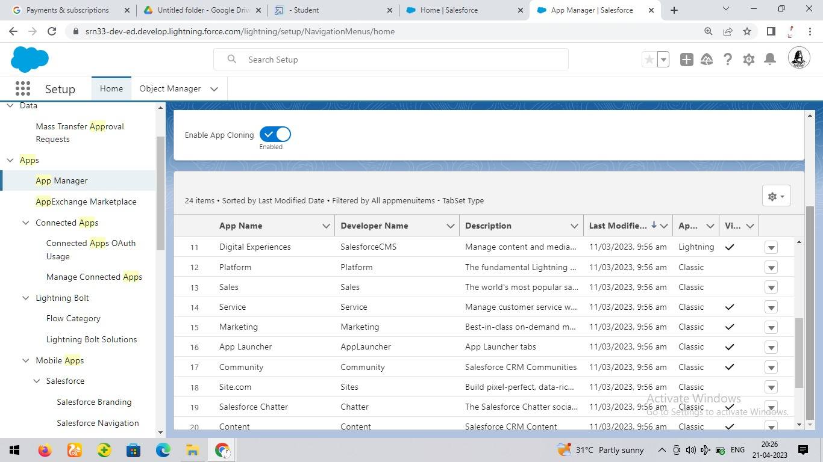

MILESTONE -04:

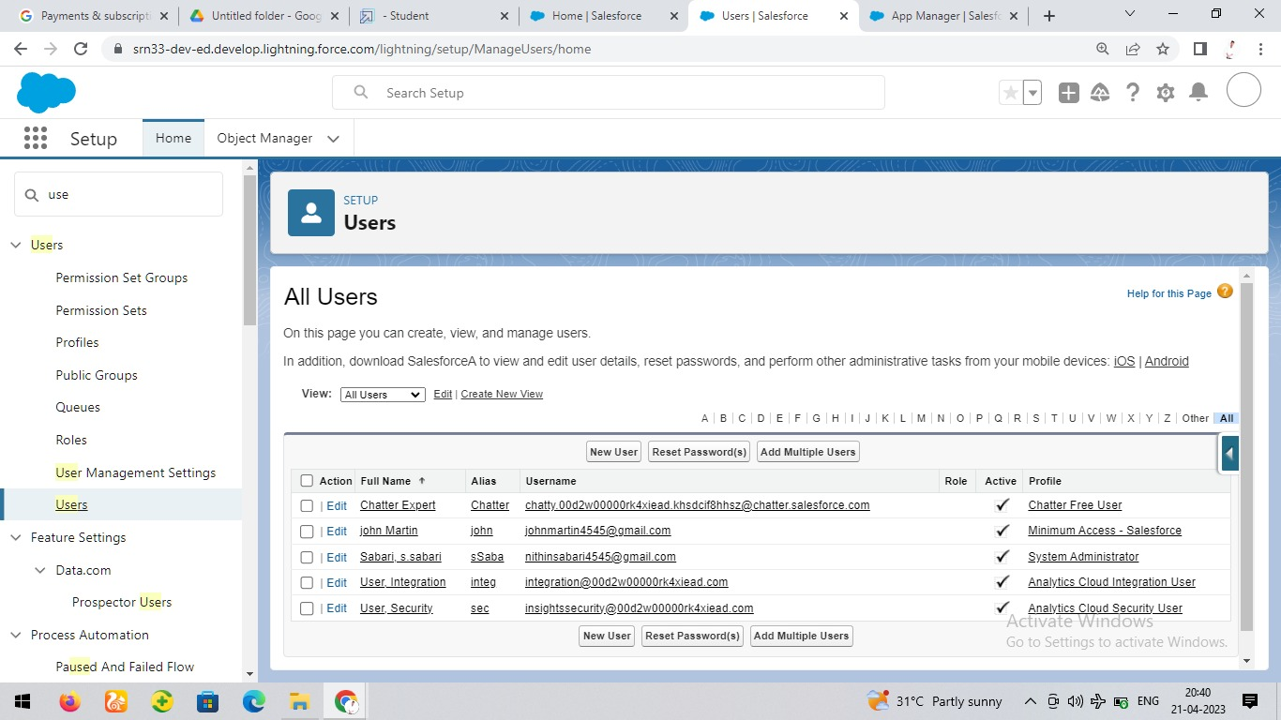

MILESTONE -05:

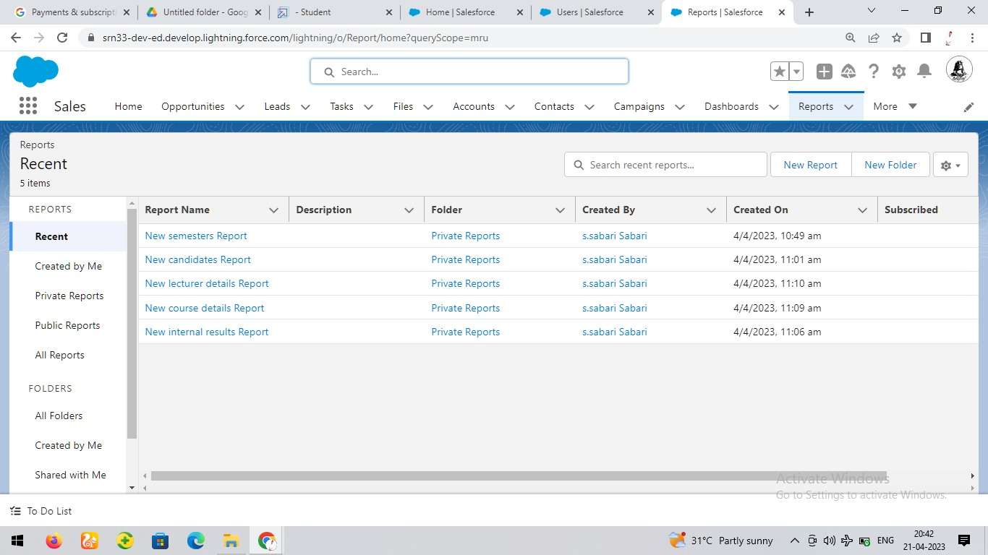

MILESTONE -06:

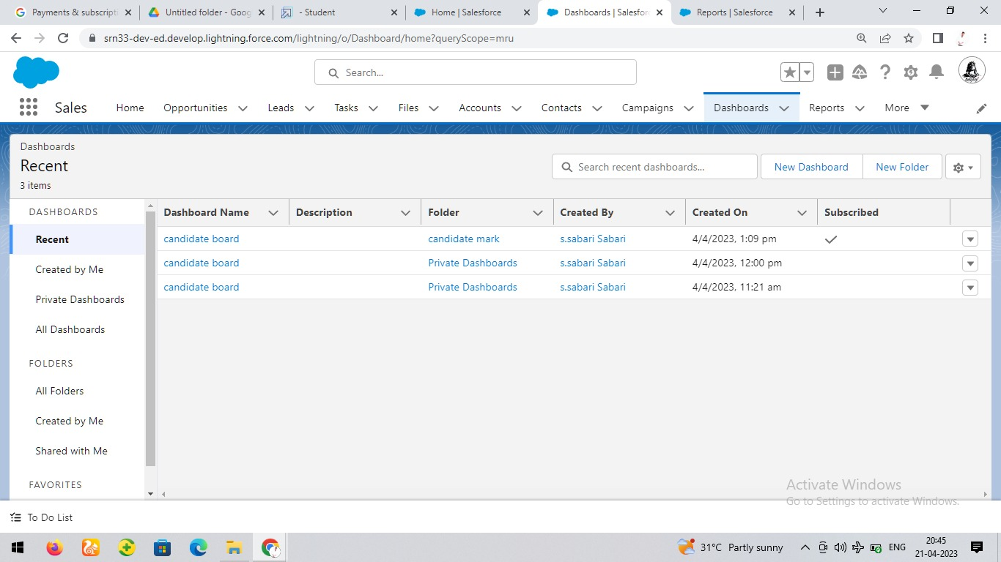

4. Trailhead Profile Public URL:

Team head: <https://trailblazer.me/id/sriram2002>

Team member 1: <https://trailblazer.me/id/rajkumar2003>

Team member 2: <https://trailblazer.me/id/sabari13>

Team member 3: <https://trailblazer.me/id/nkumar2850>

5. ADVANTAGES & DISADVANTAGE :

A CRM can help you identify customer needs, track feedback, and manage your customer service improvements. The reporting features also allow you to track customer metrics from several different sources, such as help desk metrics, customer satisfaction scores, and more. Certain businesses where customer transactions are highly standardised may not benefit from a CRM system. A CRM system works best where personalisation is required in client/company interactions and where there are multiple touch-points over time between the client and the business across departments.

The advantages of a CRM system are available to salespeople, marketing teams, customer service professionals, and anybody who interacts with customers in large and small organisations.

6. APPLICATIONS :

Customer relationship management (CRM) is a technology for managing all your company's relationships and interactions with customers and potential customers. The goal is simple: Improve business relationships. A CRM system helps companies stay connected to customers, streamline processes, and improve profitability. CRM can analyze data and generate reports whenever required. There are mainly three types of CRM applications – Operational, Analytical and Collaborative to perform all these activities. Web CRM applications are excellent as an add-on service to your desktop application. As such, you will certainly use them when you can not use your own computer or phone. At the same time, they can be used in companies where most employees work with Outlook, but some of them prefer .

7. CONCLUTION:

Customer Relationship Management enables a company to align its strategy with the needs of the customer in order to best meet those needs and thus ensure long-term customer loyalty.

CRM in retail allows businesses to make smarter decisions to better serve their customers and maximize profits from repeat purchases. By implementing a CRM into your retail sales process, you can enhance customer relationships by providing personalized service that caters to their individual needs

Customer profitability analysis allows you to segment your customers by their profit contribution to your brand and optimize your marketing, customer service, and operations costs around the customer segments who are the most profitable for your brand.

8. FUTURE SCOPE:

With the help of a CRM system, companies solve sales problems, increase the productivity of employees, and regularly monitor important financial indicators. According to EPCGroup's analytics, CRMs exploded in 2022, achieving an 11.6% CAGR from 2022 to 2027. Customers will become a company's best sales reps through superior products and services as well as customer-oriented messaging. The future of CRM is more than just the future of Customer Relationship Management software. It is really the future of business. Report Overview. The global customer relationship management market size was valued at USD 58.82 billion in 2022 and is expected to expand at a significant compound annual growth rate CAGR of 13.9% from 2023 to 2030